Digital Diary System

Table of Contents

**Introduction** 3

**General Diary System** 3

**Digital Diary System** 4

**Aim and Objective** 4

**Application of Digital Diary** 5

**Ethical and Legal issues** 6

**Previous Work** 7

**Methodology** 11

**Hardware** 11

**Software** 12

**Operating System** 13

**Technology** 14

**ASP.Net** 14

**Visual Studio** 15

**Microsoft SQL Server** 16

**Experimental Setup and Analysis** 17

**Conclusion** 23

**References** 23

# **Introduction**

Diary is used from the old era for keeping the notes and future planning. It helps people to make life and work easier as they can view the planned tasks in a single notebook. Diary is of different types. Some of those contain pages with date and months and some other contains the plain whitepaper. Those who have huge works and think that they may forget it, use to keep their task into the diary so that they can check for their planning. This was the way how people had conventionally used the diary. The diary is everywhere like in School, College and other educational institution also (Wada, et al., 2012). In-School, the student and teachers use to maintain an individual diary to intimate the teacher with their regular task and applications. Teachers use to provide the student with some problem and the parents are informed by the teacher with the comments of the solutions whether it was good or bad. Additionally, if the student wants to leave for a day or a couple of days, the student can write an application to the concerning teacher with the reason of their leave in an application (Bryan, et al., 2013). The diary is checked by the concerned teacher every day and they will decide whether the leave will be sanctioned or not. So, it means the teacher should take a look into the physical diary everyday from each of the students.

## **General Diary System**

A diary is a hard book where the thought and expressions are written by the people every day. The purpose of the diary is mainly developed for keeping the memory which can be checked in future. This will reflect the minute observation of the moments of the person which he had faced. The purpose of keeping a diary in a day to day basis is to avoid the nature of forgetting the issues that had been occurred to him in past. People also keep the diary to make the documents of their appointments and meeting in the future days which he might forget (Debi, et al., 2020). To keep the memory updates, everything is recorded in the diary. Conventionally, people who keep the diary for recording the moments and appointments, generally access a pocket diary which is feasible and easy to carry. The diary provides the people with an intimate glimpse of his workings and feelings of his mind (Ferrari, et al., 2016). The diary can also be considered to be the historical record of some continuous event which the people do not want to miss. Such, for instance, was the diary of Samuel Pepys, a writer who lived in the second half of the seventeenth century. His famous diary gives us a picture of contemporary events like the coronation of the king, the Great Plague and the Great Fire of London. It is of great interest and importance to students of English literature and history (Gogh, et al., 2017).

## **Digital Diary System**

The physical diary system is good as it is the traditional way to keep notes. The main issue of the physical diary system is the possibility of losing it. As it needs to be carried, there is the possibility of losing on the way of travel. If so, the entire records will be lost and it cannot be recovered if there is no backup. Most of the people use to write down their appointments without backup. So, the loss of the diary may incur a severe problem to the people. On the other hand, if the diary is considered for the school purpose, teachers need to check all of the student diaries minutely and this will consume higher time (Lepp, et al., 2020). Apart from the problems of the physical diary for loss and time consumption, another issue is the style of living and usage. As technology is progressed, everything goes digitised. Naturally, with the development of Smart Mobile and internet technology, people widely use interactive applications which is available online (Saks & Leijen, 2019). One of the famous application that is available online is the Digital Diary. In those diaries, people can log in to the system and write their memories and store it. In this context, the diary need not be carried from one place to another rather it is monitored and maintained by the remote server. The server uses the database which keeps the documents of each user and stores the moments and notes in their account concerning the identity of the users.

So, if this digital diary system will be initiated in the school or other educational institutes, it will be advantageous to the students as there will be no burden to carry the diary and they can simply write their notes and application through mobile or laptops (Wada, et al., 2012). Thus it will simplify the application and the thinking of the diary system and the teacher will feel relaxed from checking all the physical diaries.

## **Aim and Objective**

The paper aims to design a Digital Diary system which will help to interact with the student and the teacher using the digital intermediate system. The system will be designed so that the student and the teacher can access it remotely (Liao, et al., 2015). The Digital Diary system will be monitored by the server where the database of the student and teachers will be stored. The database contains the user credential such that the user identity, password, name etc. Users are the students and teachers who have the provision to use the system from anywhere.

The objectives are taken to create the Digital Diary are:

* To design the Digital Diary that can be accessed through the webpage.
* To use technology like ASP.Net to design the website.
* To consider the associated technologies for creating and designing the website like the HTML, CSS & JavaScript.
* To assign the database where the data of the users will be stored.
* To allocate the login panel on the website where the student and teacher can log in to the system and access the facilities.
* To store the details of the student and the comments of the teacher in the database with the corresponding date and student name.

## **Application of Digital Diary**

The digital diary can be applied anywhere depending upon the needs of the human. As technology goes digitised and the devices become portable, the technology should be connected to that. Nowadays, everyone has a mobile or laptop or a tablet pc. People always carry one of those and mostly the mobile phone with them. As most of the mobile phone has the Android Operating System, it is connected with the play store from where the user can download and install the digital diary system (Jilek, et al., 2015). In these systems, the user will have to log in and then create their notes and all. So, in such a diary system, the user needs to put their credential to the public server and not for all the time it is secured. However, the digital diary is one of the famous application through which the users can send their personalised notes or the application or any write-ups to the preferred or targeted one without any physical visit (Liao & Dogaru, 2016).

Electronic Diaries are a manner of preserving a replica of a diary on a pc. This permits the consumer to browse their appointments, and mark appointments on digital "diary pages". Since the pc holds the info of every appointment customers may be reminded earlier of conferences and appointments. The use of computer systems additionally introduces flexibility into the layout of diaries, providing one-of-a-kind views, together with via way of means of year, month or week. Unlike a paper diary, the pc routinely provides new pages whilst needed, more room for every day, and keeps copies of diaries for years long gone past (Gadanecz, 2018). While that is useful, the maximum vital benefits of a digital diary over a paper one is in its potentials to be shared. Unlike a paper diary, that's certain to at least one place, the workforce can get entry to a digital diary over a pc network, checking to peer whilst different workforce are free. Moreover, the workforce can percentage a diary, permitting a secretary to run a supervisor's diary, even as nevertheless permitting the supervisor to get entry to over the pc network (Fassbinder, et al., 2017). Electronic diaries hung on computing device computer systems, then, make reserving conferences a whole lot easier. Digital diaries permit conferences instances to be found, arranged, and confirmed, all from the pc, saving time and bother. While those capabilities are useful, a digital diary does upload a few complications. Electronic diaries which are hung on computing device computer systems aren't as transportable as paper diaries. This has led a few groups to increase the number of transportable "private organisers" - the "Palm Pilot", "Psion" and "Timex Data Link watch" being 3 of the maximum popular (Lin, 2013). These are small transportable computer systems that try and offer the capability of a "Filofax" in digital form. While useful, those computer systems are nevertheless possibly something of a novelty. While diaries held in private organisers are greater transportable, they can't be shared over the network. Compatibility among transportable organisers and pc diary applications may also dramatically boom the usefulness of the use of digital, instead of paper, diaries (Ferrari & Mamei, 2016).

## **Ethical and Legal issues**

While the most common use of an academic year diary is to organize your academic duties, it can take on many forms and serve many purposes. And this makes them so versatile and helpful. The diary can log classroom experiences. For example, you can write journal entries about your time in the lab for chemistry class, your experiences putting together a group project for business class, or how you performed research for a thesis paper in a literature class (Cunningham, et al., 2016). Another practical example of an academic diary is one used to help with retaining course material. While you may think you can remember every little thing that gets thrown at you, by keeping a diary of what you have been told, you will soon wonder how you ever coped without one. A diary can also help with recording ideas for certain classes (Rajkumar & Ganapathy, 2020). For instance, imagine you have to write an essay on a famous poet. While eating lunch, an idea for a thesis pops into your head. If you have your academic diary with you, that idea can be written down and it won't slip away.

As for the online service, the digital diary consists of significant risk factors that are associated with the loss of identity. The credential contains the user mail id and the password or the combination of the phone number and the password (Refat, et al., 2019). For the real-life scenario, the user mail id and the passwords are generally associated with the financial document like the bank account and national identity card. In such a case, those are sensitive information that can be breached through the internet by hackers. So, along with the facilities provided by the digital diary, security is a major concern. Thus to use the digital diary, the ethical and legal considerations to be followed (Refat, et al., 2020). The ethical and legal considerations are:

1. When the user will input the credential, the hackers may check for it by penetrating through the network and can steal the data of the user from their devices.
2. Before using the digital diary, the check for the digital certificate is necessary. If the application is launched by the hackers to falsify the users, the user may be the trap. If the user will download and install it, the hacker can also access their financial account by causing serious loss (Shin, 2020).

# **Previous Work**

There are different works has been done earlier by different researchers who had introduced the digital diary and online diary system to facilitate the user with many aspects like the education and e-learning process. Different technologies have been used for the design and deployment of the digital diary system which has caused massive advantaged to the users.

(Debi, et al., 2020) have proposed for the online diary which can be used to keep the records for the money transaction. As the matter is the finance, they have proposed for the security system which prohibits the hackers to get access to the user account. In their development, they have chosen the Android operating system which is the widely used mobile operating system in the world. It means, they have initiated and developed the mobile application which can be downloaded from the play store and install in the mobile phone easily. The reason for creating this application for the assistance the users for managing their financial activities and tasks within a single application. The research method that has been used in the data collection is basically indirect observation and the literature study. The development of the application follows the method that uses the system development life cycle method using the waterfall model. This waterfall model facilitates the sequential and systematic approach which is initiated at the level of the user requirement and flows to the level of maintenance. This application is launched in the Android platform only through the implication of the Java programming language. This diary can be used for the observance and remembrance of the daily actions which reminds the users of several things like the payment of the bill on time, to manage the financial account on time, to remind users to perform certain actions that were previously planned etc. So, this application is provisioned with the enormous facilities that can attract users.

(Bryan, et al., 2013) have proposed their method to create the digital diary to use it in the egocentric network. The contact diaries are used to keep the logs of the interpersonal communication that are achieved in the epidemiological and sociological studies. Those logs can be applied in the study for the understanding of the social patterns of the communities within a long period of time. A dataset is especially comprised of the map of the diaries in the form of a set of categorical, one-tiered, egocentric and independent networks. Their paper represents the interface for the analysis and the visualization of the datasets of contact diaries that is used by the interactive radial mapping scheme. With the previous case studies on than similar matters, those were illustrating the standard workflow by using the diary application. But among all of the applications and the utility services, they have identified the waterfall model to be a good choice.

(Ferrari, et al., 2016) have proposed for the application and the underlying challenges that are associated with the digital diaries. As the technology is progressed and holding the position of the digitisation, people are using the software application with a passion for all of their purpose. This is mainly for the portability and flexibility of application which can be stored in the mobile phone or in the tablet pc digitally. Every time, the user need to note something, they only need to unlock their device where the application is stored. After that, they can open the application and write a note about whatever they want. After writing the notes about the moments or for some important work, the note can be saved digitally. This need not requires even extra space as the note of the digital diary can be stored in the cloud storage. The cloud storage can be provided by the application provider or it can be the personal cloud account of the user. However, most of the time, the user access the cloud storage that has been provided by the application provider of the digital diary. This can be a risk in the system as the hackers are there to steal the important document of the users. If the user will keep their financial documents in the diary and store it into some cloud storage, this becomes a vulnerable issue and the important document can be stolen. This is the primary risk and challenge of the digital diary. Additionally, with the stealing of the user document from the cloud, the hackers target the user device at next. So, this kind of challenge can be faced by the user if they are not aware of the cybersecurity and just download and install it. This because the hackers only want to the user to install the application and there they can access the user account.

(Lepp, et al., 2020) have proposed for the creation and maintenance of the video diary which works upon the video recording and tutoring the student by the teacher. In the conventional system was approached for keeping the notes by wringing and storing into the cloud or personal storage. As technology and understanding become interactive, the preferences have been moved to the video model of a diary. The diary with writing can only show the documentation and cannot reflect the emotion of the storyteller or the educator wherever applied. In the domain of education, the style of teaching the exaggeration is the important thing to attract the student towards the subject matters. Thus, no only the writing of the notes places the impact on the topic and thus, they have approached in a new way to design a diary where the video notes can be stored. The main aim of their study and research is to find the advantages and disadvantages of the study system and understanding the views of the concerned teacher towards the students. By identifying the needs and the requirement, the teacher can prepare the video lecture and store it in the cloud storage. In this scenario, the cloud storage can be accessed by the students using the proper login. The teacher can also prepare a note which can be viewed by the student in the form of lectures and the corresponding video can be designed to demonstrate this. They have made the experiment of how the video diary system will facilitate the students and thus they have made the questionnaire to keep the record for the responses. In this context, they have surveyed 24 teachers by telling about the fact and taking the responses from them. The dataset which includes the results of questionnaires from 24 teacher students and video and written diary posts by 18 of those students. Then, the data has been analyzed by using the deductive and inductive process of the content analysis. The results of the study have shown that the video diary is advantageous over the normal and digital written diary as it includes the authenticity and emotions, faster compilation, and is obviously the true alternation of the written diary and work. But there are some disadvantages that they have identified during the research like the fear for being in front of the camera, the issue of recording and unload due to the internet and technical problems, the proper choice of the location for recording the video etc. Apart from the disadvantages, they have found the video diary is a proper alternative in the field of the digital diary.

(Saks & Leijen, 2019) have investigated the role and utility of digital learning in the present educational system. Preparing the learners for the demands of the present and upcoming era requires the innovative, committed and the teachers willing to push the existing restrictions into the bounds. It is also for the effect that uses the growing technologies that enhances the process of teaching and learning strategies in the digital domain. This is to be mentioned that the present era is based on the digital revolution of the technology and for this issue, people are mostly favouring this as in the part of their education system. The rapid and unique changes are happening in the field of education and others present various problems for teachers who are wishful to teach the student in an interactive way. In this context of digital learning, the diary system enhances the process strategy and make the system easy. Using the digital diary, the student can write an application which can be accepted or rejected by the teacher. This is a good facility which prevents the present teaching and learning process from wasting the time of written application of the application over the phone. The digital diary can be made such that the application will go to the applicable teacher and he or she can act upon this. So, by integrating the technology into the field of the education can facilitate then educationist and the educators with a range of facilities that can transform the entire system to the digital one to achieve new learning goals. Incorporating technology in the classroom can bring significant and positive changes in the teaching-learning process but it is not at all easy as we have strong conventional educational practices in our education system and integrating ICT will demand the innovative role of the teacher as a facilitator of the learning to the active role of the learner. The present paper focuses its attention on the problems and issues of the classroom and teaching-learning process in the digital age as it won’t be easy to break existing pedagogical practices and adopt new ones.

(Gogh, et al., 2017) have emphasised on the digital diary on the present online and digital learning system. The schools and colleges or more specifically the educational institutes today shape and serve the world in which there is a huge opportunity for growing up if the people can work in a creative manner and collaboratively. However, instead of the fostering the human uniqueness and the creativity, a number of school and college systems have become preoccupied with the traditional structure of curriculum with the uniformity and pedagogical practices. The college and the schools along with the teachers and professors have been bound into the web of test scores and achievement targets. By and large, our schools are preparing young people to grow up well and transfer to digital life. the education in the 21st century is no longer within the four walls of the classroom and rather it has been flourished with the emergence of the technology with digital media. The technology has been enlarged with the area of the process of teaching and learning. The learners can avail the vast source of information from the internet and they can have a lot of queries for this reason. They can also place their queries ton their teacher through the online portal or through the digital diary where the teacher can solve the problem and makes it simpler to be understood. So, to understand the harder topic, they only need access to digital technology like the internet and web browser through which they can be clarified with their doubts by the teacher online. So, the traditional practices should be changed necessarily as the incorporation of ten newer technology is capable enough to provide opportunities to the learners to discover the answers. It is also a fact that teaching has always adapted to its circumstances methodologically and physically, moving from lecture to pair work and from translation to communication, for example. Likewise, teachers have always tried to make the best use of any materials that they could get their hands on – from slate to whiteboards, from hand-written postcards to authentic magazine articles, from radio recordings through to DVDs. They have implemented the digital diary to be used in the school and colleges. The implementation of the digital diary and the use of it facilitates significantly the administration and also allows the lucrative features that are lacking in the case of the paper-based diary.

# **Methodology**

The digital diary can be run through the operating system which required different components like the hardware, software etc. To run the system smoothly, each of the entities is essential and if some of those will be losing its operation, the entire system can be malfunctioning (Azmi, et al., 2012). So, the digital diary and its architecture will be based on the hardware and software components which will be discussed here.

## **Hardware**

The hardware is the skeleton of the computing system like the computer hardware, the motherboard, parts of the mobile etc. The installation of the software re dependent upon the configuration of the hardware. Each of the software has its specific requirements so that it can work smoothly in a computer or mobile system. A computer is a programmable device that accepts input, stores and manipulates data, and affords output in a beneficial format (Baykara & Gürel, 2018). A laptop is made of an aggregate of additives, that's hardware and software program. Both additives are essential and feature their personal features and significant usages. The most effective definition of hardware is the aspect which we are able to contact and software program is the aspect which we can not contact however most effective feel (Bhor, et al., 2018). Computer hardware is the bodily the mechanical, magnetic, electronic, and electric additives making up a laptop machine. Examples laptop hardware are Central Processing Unit (CPU), Random Access Memory (RAM), tough disks, CD-ROM Compact Disk Read-Only Memory), keyboards, mice, printers, modem, router etc. The computer software program is the specified commands that manipulate the operation of a laptop machine (Bryan, et al., 2013). The computer software program is split into fundamental kinds of software program, that's machine software program and alertness software program. The system software program is hard and fast of generalized applications that control the laptop’s resources, which include CPU, conversation links, and peripheral devices (Chen, et al., 2015). Examples of machine software program are Microsoft Windows, Mac OSX, Linux, BIOS software program, Device Diver Software etc. Application software program describes the applications which can be written for or via way of means of customers to use the laptop to a particular task. Examples of utility software program are Microsoft Word, Mozilla Firefox, E-mail software program, groupware etc (Cunningham, et al., 2016).

For the initiation of the design and to drive the digital diary system, certain hardware specifications are required from which the relevant technology for digital diary can run. The high-end RAM and High-Speed processor are required to run the digital diary website through the local server (Thams, et al., 2020).

## **Software**

Software is a wide time period for the applications strolling on hardware. Familiar sorts of software program are working structures, which offer ordinary manage for laptop hardware, and applications, which might be optionally available applications used for a specific job. Software is living on disks and is introduced into reminiscence while it's far needed. Often a difference is drawn among software program and firmware. Firmware is software program this is semi-completely positioned in hardware (Son, et al., 2019). It does now no longer disappear while the hardware is powered off, and is regularly modified via way of means of unique set up tactics or with management tools. The reminiscence firmware makes use of could be very fast — making it perfect for controlling hardware in which overall performance is important. For example, NETGEAR routers clear out the use of firmware, which has a tendency to lead them to quicker than a PC or Macintosh acting a comparable function. A software program or firmware improve makes an everlasting alternate — typically a development in features, in overall performance, or to accurate mistakes (Bryan, et al., 2013).

Beta software program or firmware is an improve that has now no longer been very well examined. Some conditions which can most effective be examined via way of means of setting system withinside the real scenario it'll work. The beta software program and firmware is a long way much more likely to have insects than the polished very last versions. Beta firmware can also additionally alternate hastily while mistakes are determined and corrected via way of means of the makers (Cao, et al., 2019). For those motives, NETGEAR makes beta software program and firmware available, however, can not offer a technical guide for it. A motive force is a software program and/or firmware that controls hardware. Often it connects a working gadget with particular hardware devices. For example, there are drivers for each card and disk for your laptop. Each motive force is written for a selected working gadget — as an instance Windows XP or Macintosh OS X (Wang & Zhang, 2015). Therefore, to apply a card for your laptop, you ought to use a motive force that fits the tool and additionally the working gadget. Drivers may be enhanced, as an instance, while new working structures come out. Eventually, hardware turns into so vintage it's far not within your budget or sensible to provide new drivers for it (Terenziani, 2017).

## **Operating System**

The OS performs a crucial position in relation to the beginning and closing down the pc which is likewise called booting. Six steps take vicinity while a pc is booting: The first step starts as quickly because the pc is grown to become on, the electric sign reaches to the additives withinside the gadget unit thru the electricity supply (Song, et al., 2018). During the second one step, the processor chip is reset because of the electrical sign after which it locates the ROM that consists of the primary input/output gadget (BIOS), that's a firmware that consists of the startup commands of the pc. Next, the BIOS launches a chain of assessments to make certain hardware are operating and related properly, called the electricity on self-test (POST), commonly while the POST launches, the LED lighting fixtures of the gadgets flicker, at instances there might be messages showing at the display. The fourth step takes vicinity while the POST compares the end result with the complementary metal-oxide-semiconductor (CMOS) chip data (Son, et al., 2019). CMOS makes use of battery electricity to keep the facts, data, and reminiscence while the pc close down. Besides that, it detects new gadgets and identifies them while those gadgets are related to the pc. The “beep” sound commonly consequences while the CMOS detects which later observed through the mistake messages. The 5th step proceeds while the POST completes with none interference wherein the BIOS will find the OS documents additionally called the gadget documents from any supply of drive. The 6th steps take place while the gadget record is located, that's then loaded into the RAM from its garage alongside the kernel of the OS. The gadget record then launches, and finally, the OS which becomes saved in reminiscence takes manage of the entire pc gadget. During the very last step, the OS hundreds the facts setting. Certain OS might also additionally request for consumer ID and password. After the OS hundreds, it shows the laptop display and it was initiated up historical past processes (Thams, et al., 2020).

## **Technology**

### **ASP.Net**

ASP is called Active Server Pages that is produced through Microsoft Team withinside the early of 12 months 1990. Microsoft Active Server Pages (ASP) is authorized to construct dynamic and interactive internet applications. ASP traditional is without problems to permit internet software hyperlink to the database in the internet software. The internet software created through ASP does now no longer have an effect on through the usage of the exceptional form of the internet browser (Refat, et al., 2020). The default programming language to construct ASP internet web website online is the usage of VBscript to build, however, it's miles help different programming languages like JScript (JavaScript from Microsoft). But ASP.internet lets in internet developer use both visible basic (VB) or ASP.internet language to construct internet applications (Lin, 2013). An ASP web page is saved at server-side. So, the patron can not without a doubt view an ASP web page at the internet browser. They want to request the ASP web page via the internet server that helps for ASP. When a patron requests an ASP web page via the internet browser, the internet server will locate the ASP record at the difficult power and interpret it. After that, it's going to get rid of all of the ASP Script and update them with HTML Text. ASP is the usage of HTML controls to have interaction with the user (Blanco & Tuya, 2017). Although ASP is having few precise capabilities to construct internet software, it nevertheless now no longer best but to meet internet developer in a number of the areas. For example, ASP wishes to code all of the matters in an internet web page which includes the capabilities and interface. It isn't very comfortable whilst want to adjust or replace a number of the records on the internet web page. Besides that, some other dangers the usage of ASP traditional to construct internet web page is the loss of the overall performance and scalability, because of this that the internet web page that constructed through ASP traditional will now no longer car restoration the internet pages with the internet browser. The format of the internet web page will out of the margin and the content material can not display as what internet developer has designed for (Fassbinder, et al., 2017).

### **Visual Studio**

Visual Studio consists of a code editor assisting IntelliSense in addition to code refactoring. The incorporated debugger works each as a supply-degree debugger and a machine-degree debugger. Other integrated features consist of a bureaucracy fashion dressmaker for constructing GUI applications, internet fashion dressmaker, magnificence fashion dressmaker, and database schema fashion dressmaker (Debi, et al., 2020). It permits plug-ins to be brought that decorate the capability at nearly every degree – along with including help for supply manage systems (like Subversion and Visual SourceSafe) to including new toolsets like editors and visible designers for domain-particular languages or toolsets for different components of the software program improvement lifecycle. Visual Studio does now no longer help any programming language, answer or device intrinsically. Instead, it permits numerous capability to be plugged in. Specific capability is coded as a VSPackage. When installed, the capability is to be had as a Service (Vyawahare, et al., 2018). The IDE gives 3 offerings: SVsSolution, which gives the potential to enumerate tasks and solutions; SVsUIShell, which gives windowing and UI capability (along with tabs, toolbars and device windows); and SVsShell, which offers with the registration of VSPackages. In addition, the IDE is likewise chargeable for coordinating and allowing communique among offerings. All editors, designers, task kinds and different gear are applied as VSPackages. Visual Studio makes use of COM to get admission to the VSPackages. The Visual Studio SDK additionally consists of the Managed Package Framework (MPF), that is a fixed of controlled wrappers across the COM-interfaces that permit the Packages to be written in .NET languages (Jilek, et al., 2015). However, MPF does now no longer offer all of the capability uncovered with the aid of using the Visual Studio COM interfaces. The offerings can then be fed on for the introduction of different packages, which upload capability to the Visual Studio IDE.

Support for programming languages is brought with the aid of using the usage of a selected VSPackage referred to as a Language Service. A language carrier defines numerous interfaces which the VSPackage implementation can put in force to feature help for numerous capability. Functionality that may be brought this manner consists of syntax colouring, assertion completion, brace matching, parameter facts tooltips, member lists and blunders markers for heritage compilation (Kwabena, et al., 2019). If the interface is applied, the capability might be to be had for the language. Language offerings are to be applied on a per-language basis. The implementations can reuse code from the parser or the compiler for the language. Language offerings may be applied both in local code or controlled code. For local code, both the local COM interfaces or the Babel Framework (a part of Visual Studio SDK) may be used. For controlled code, the MPF consists of wrappers for writing controlled language offerings.

### **Microsoft SQL Server**

Microsoft SQL Server is a relational database control system (RDBMS) that helps an extensive sort of transaction processing, enterprise intelligence and analytics programs in company IT environments. Microsoft SQL Server is one of the 3 market-main database technologies, together with Oracle Database and IBM's DB2. Like different RDBMS software, Microsoft SQL Server is constructed on the pinnacle of SQL, a standardized programming language that database administrators (DBAs) and different IT experts use to manipulate databases and question the records they contain. SQL Server is tied to Transact-SQL (T-SQL), an implementation of SQL from Microsoft that provides a fixed of proprietary programming extensions to the same old language. Like different RDBMS technologies, SQL Server is normally constructed around a row-primarily based totally desk shape that connects associated records factors in exceptional tables to at least one another, keeping off the want to redundantly shop records in more than one locations inside a database (Terenziani, 2016). The relational version additionally gives referential integrity and different integrity constraints to keep records accuracy. Those assessments are a part of a broader adherence to the standards of atomicity, consistency, isolation and durability, together referred to as the ACID properties, and are designed to assure that database transactions are processed reliably. The centre thing of Microsoft SQL Server is the SQL Server Database Engine, which controls records garage, processing and safety (Liao & Dogaru, 2016). It consists of a relational engine that procedures instructions and queries and a garage engine that manages database files, tables, pages, indexes, records buffers and transactions. Stored procedures, triggers, perspectives and different database gadgets also are created and completed with the aid of using the Database Engine. Sitting below the Database Engine is the SQL Server Operating System or SQLOS. SQLOS handles lower-stage functions, including reminiscence and I/O control, task scheduling and locking of records to keep away from conflicting updates (Lin, 2013). A community interface layer sits above the Database Engine and makes use of Microsoft's Tabular Data Stream protocol to facilitate request and reaction interactions with database servers. And on the consumer stage, SQL Server DBAs and builders write T-SQL statements to construct and regulate database structures, manage records, put in force safety protections and lower back up databases, amongst different tasks.

# **Experimental Setup and Analysis**

In this section, the operations of the digital diary will be discussed with full analysis. The digital diary is designed based on the ASP.Net and MS SQL server. The ASP. Net has been used for the development of the digital diary and the corresponding data will be stored in the MS SQL server (Liao, et al., 2015). The digital diary is made responsive so that the user can access it from any platform like the computer, mobile etc.

Primarily, the user needs to create an account so that the diary can be accessed. The loging window is shown below:

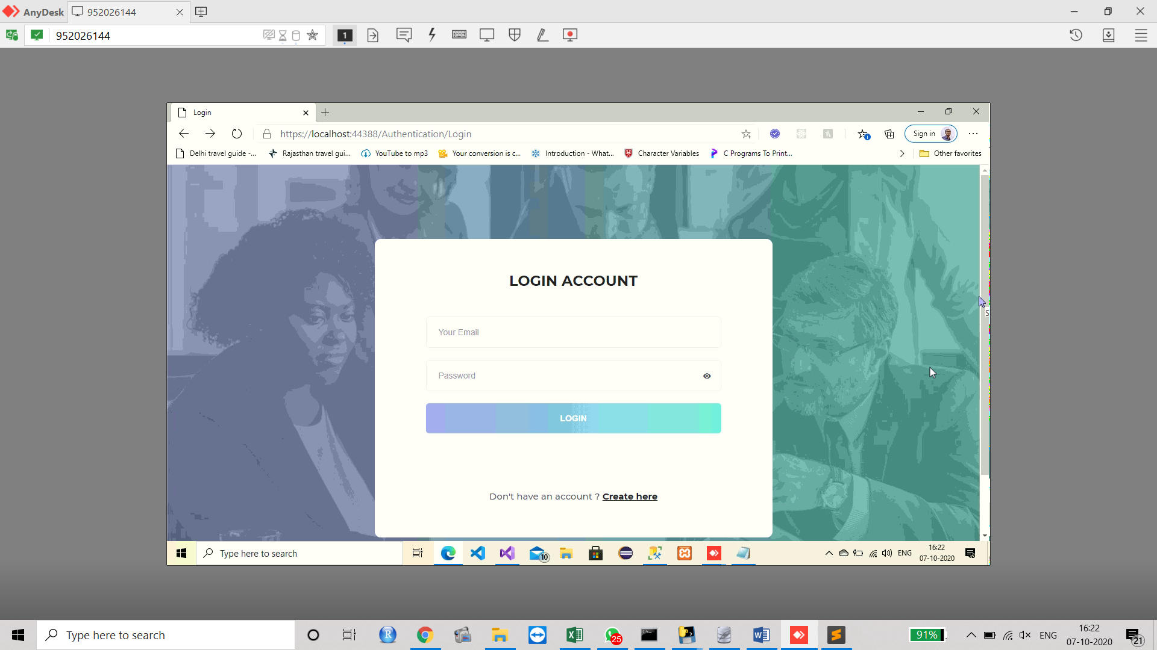

**Fig-1: Login Window**

There are two types of users in this syetm. The first one if the user or student and the second one is the admin or teacher. Both os the users need to fegister first to access then diary. The registration window is shown below:

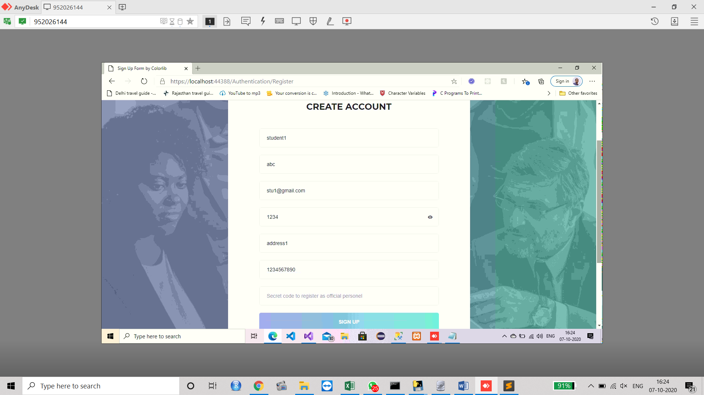

**Fig-2: Register Profile**

In the registration portal, the user needs to enter their name, email id, password, address and phone numbers (Bhor, et al., 2018). These are the common input to both of the users. If the admin is registering to the account, they need to enter one more input that is the Secret code which is 7412020. This secret code enables the user to become an admin. This secret code is only provided to the admin or the teaching staffs only. The details of the user will be stored in the MS SQL server as follows:

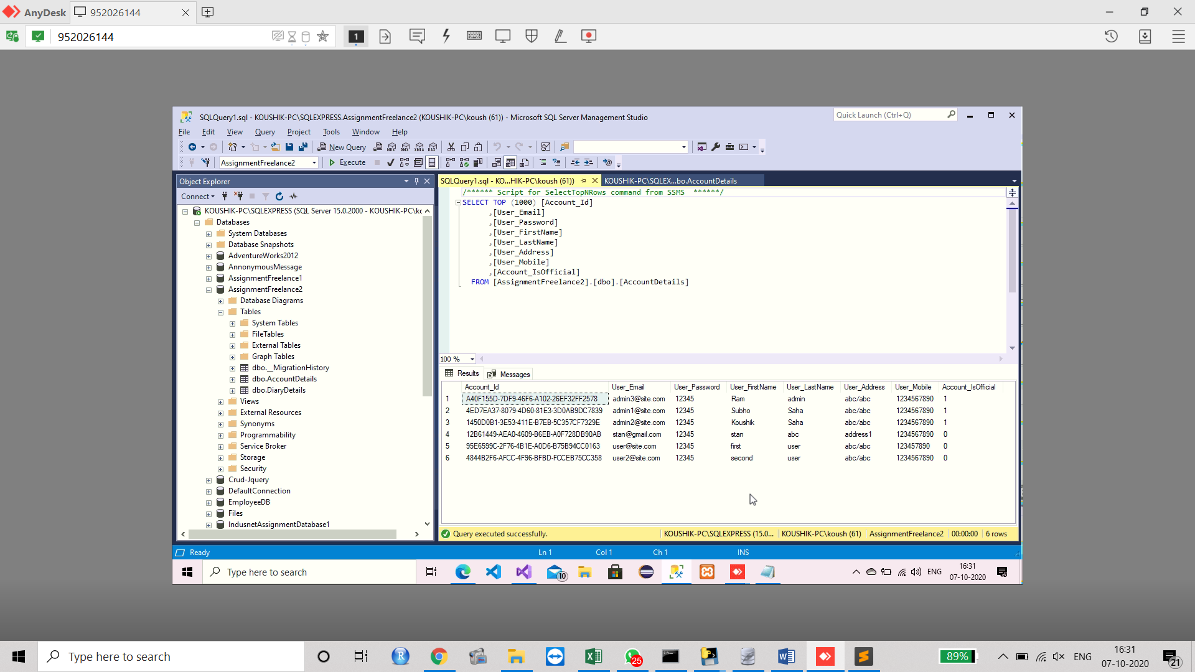

**Fig-3: SQL server to store the user data**

After registering into the portal, the user is allowed to login the system. The eligible login view is shown below:

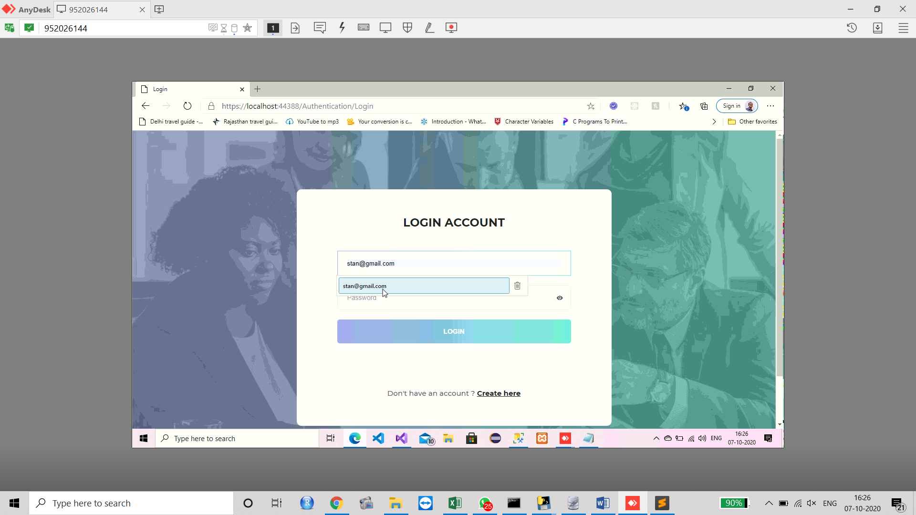

**Fig-4: Login after registration**

The system is validated with the checking of credential. If the user will insert something wrong at the time of login, the login window will throw an error as follows:

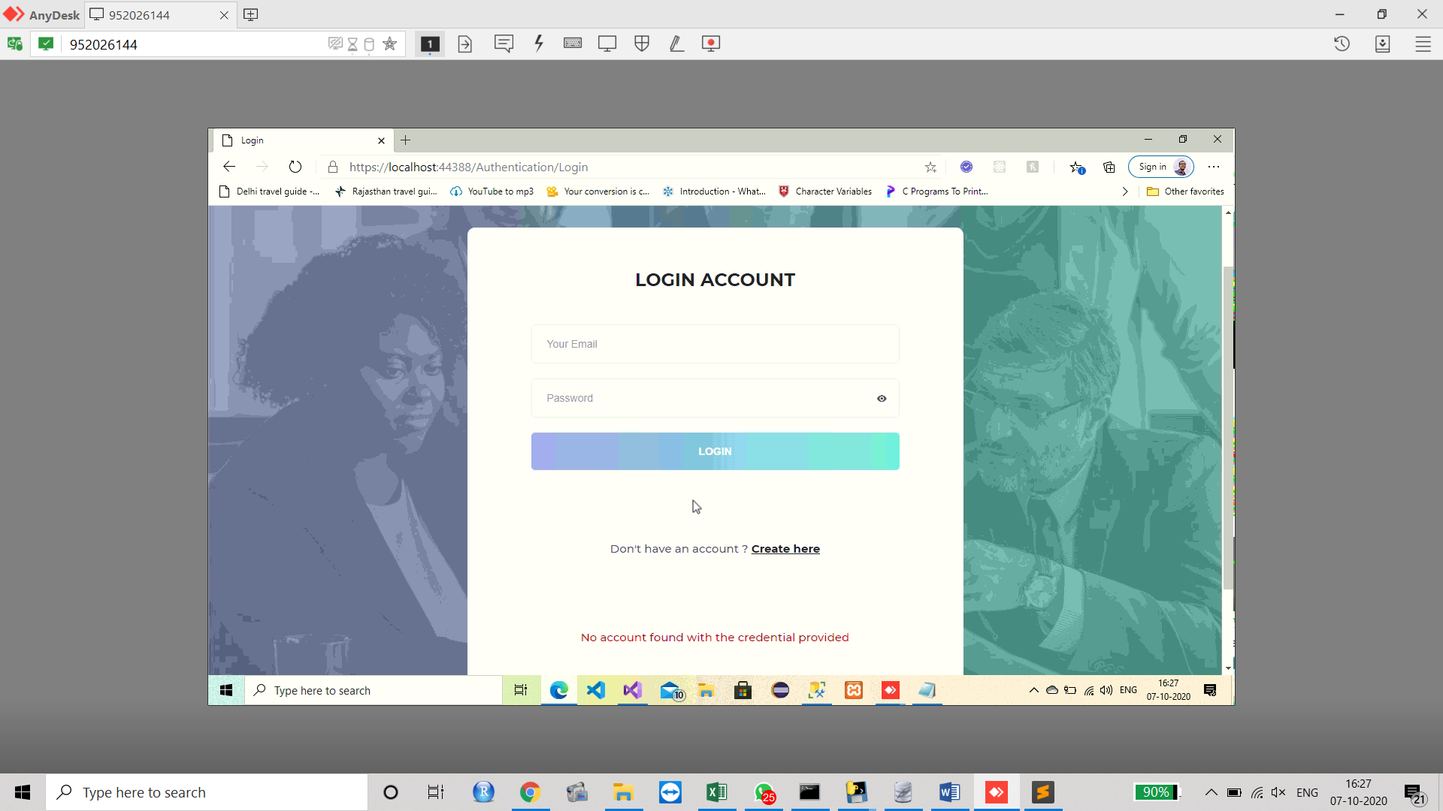

**Fig-5: Error in Login for the wrong credential**

Once the proper information like the correct email id and the password will be entered, the user will be eligible to enter into the diary system (Chen, et al., 2015). The figure below is showing the dashboard which will be appeared after propr login.

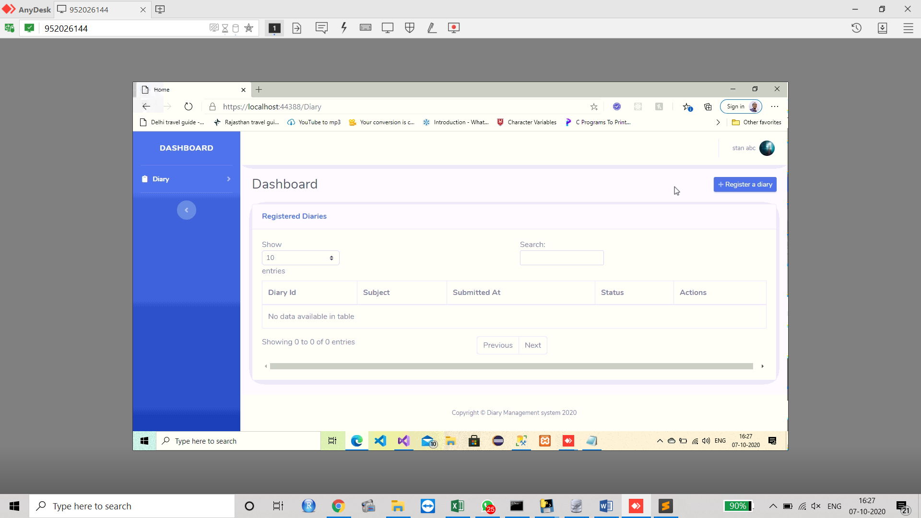

**Fig-6: Dashboard of the user**

After entering into the dashboard, the user or student can create a diary and write something int it. This facilitates the student to send the information or the application directly to the teacher who is presently the admin of the system. The diary can be created by using the selection of the “Register a Diary” option (Saks & Leijen, 2019). After the selection, the field for the diary is opened and the student can write an application to the teacher. The diary with the application is shown below:

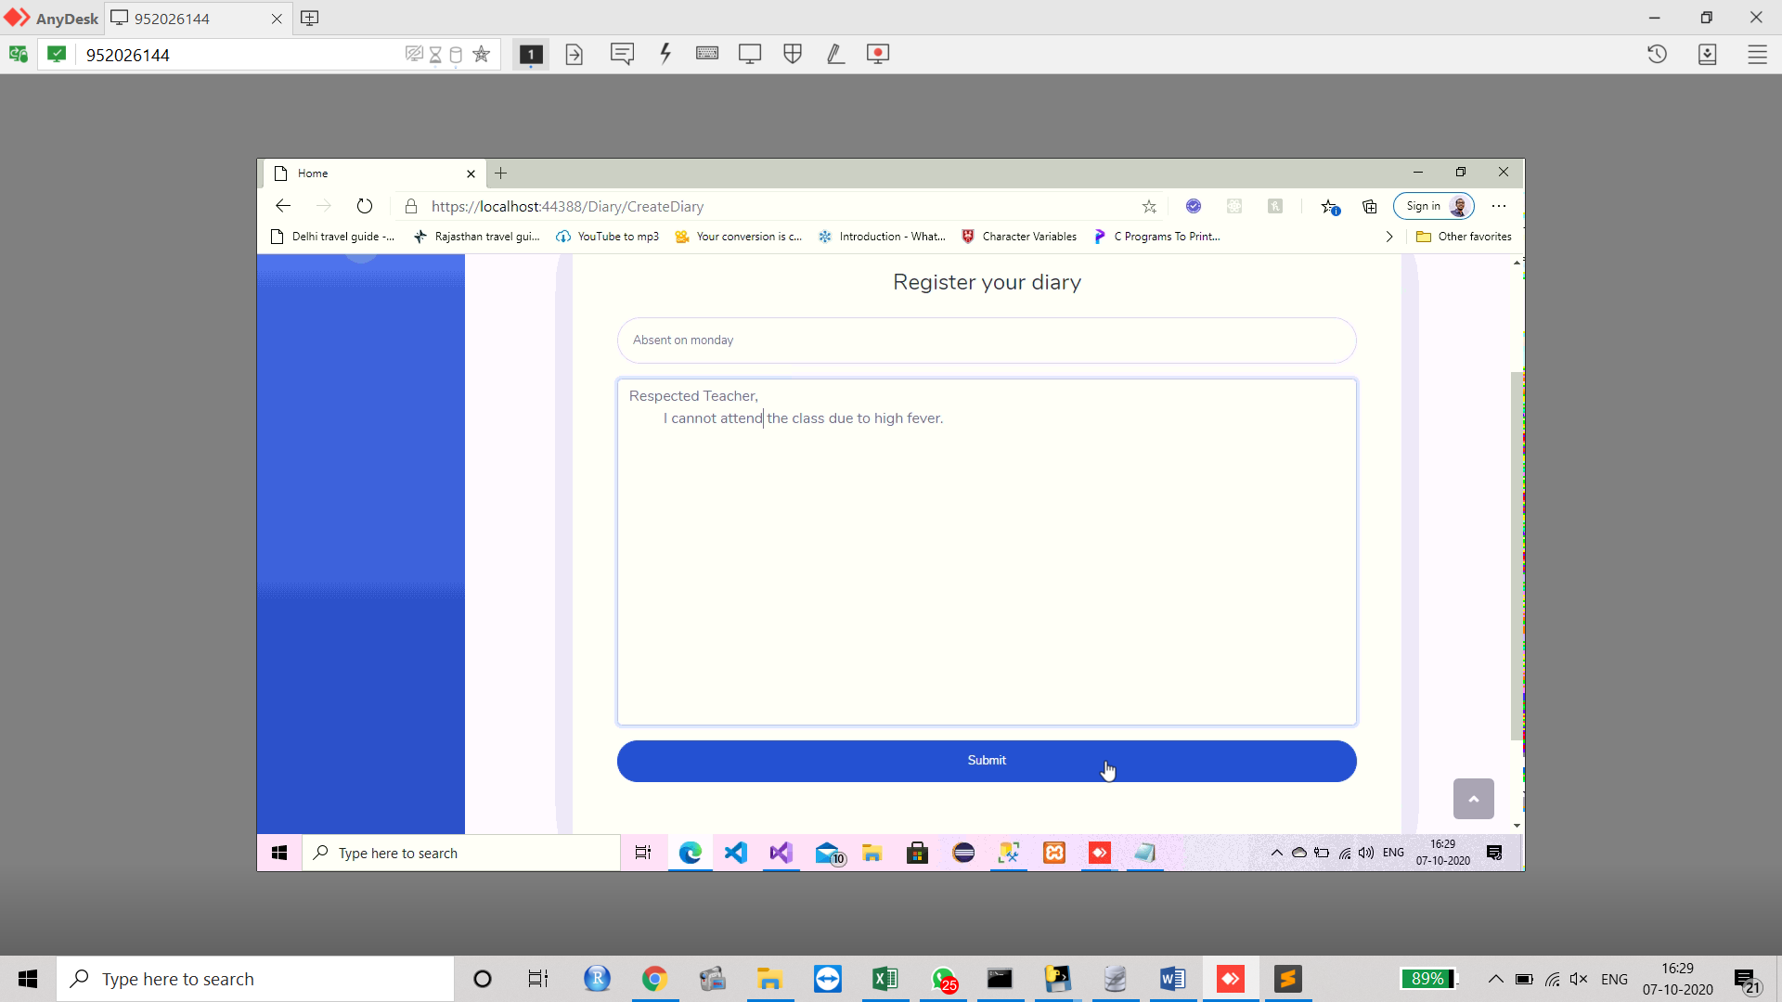

**Fig-7: Diary with Application**

After writing the application, this will be moved to the panel and will be waiting for the approval or rejection. If no action is taken, the status will be shown by “Pending” as follows:

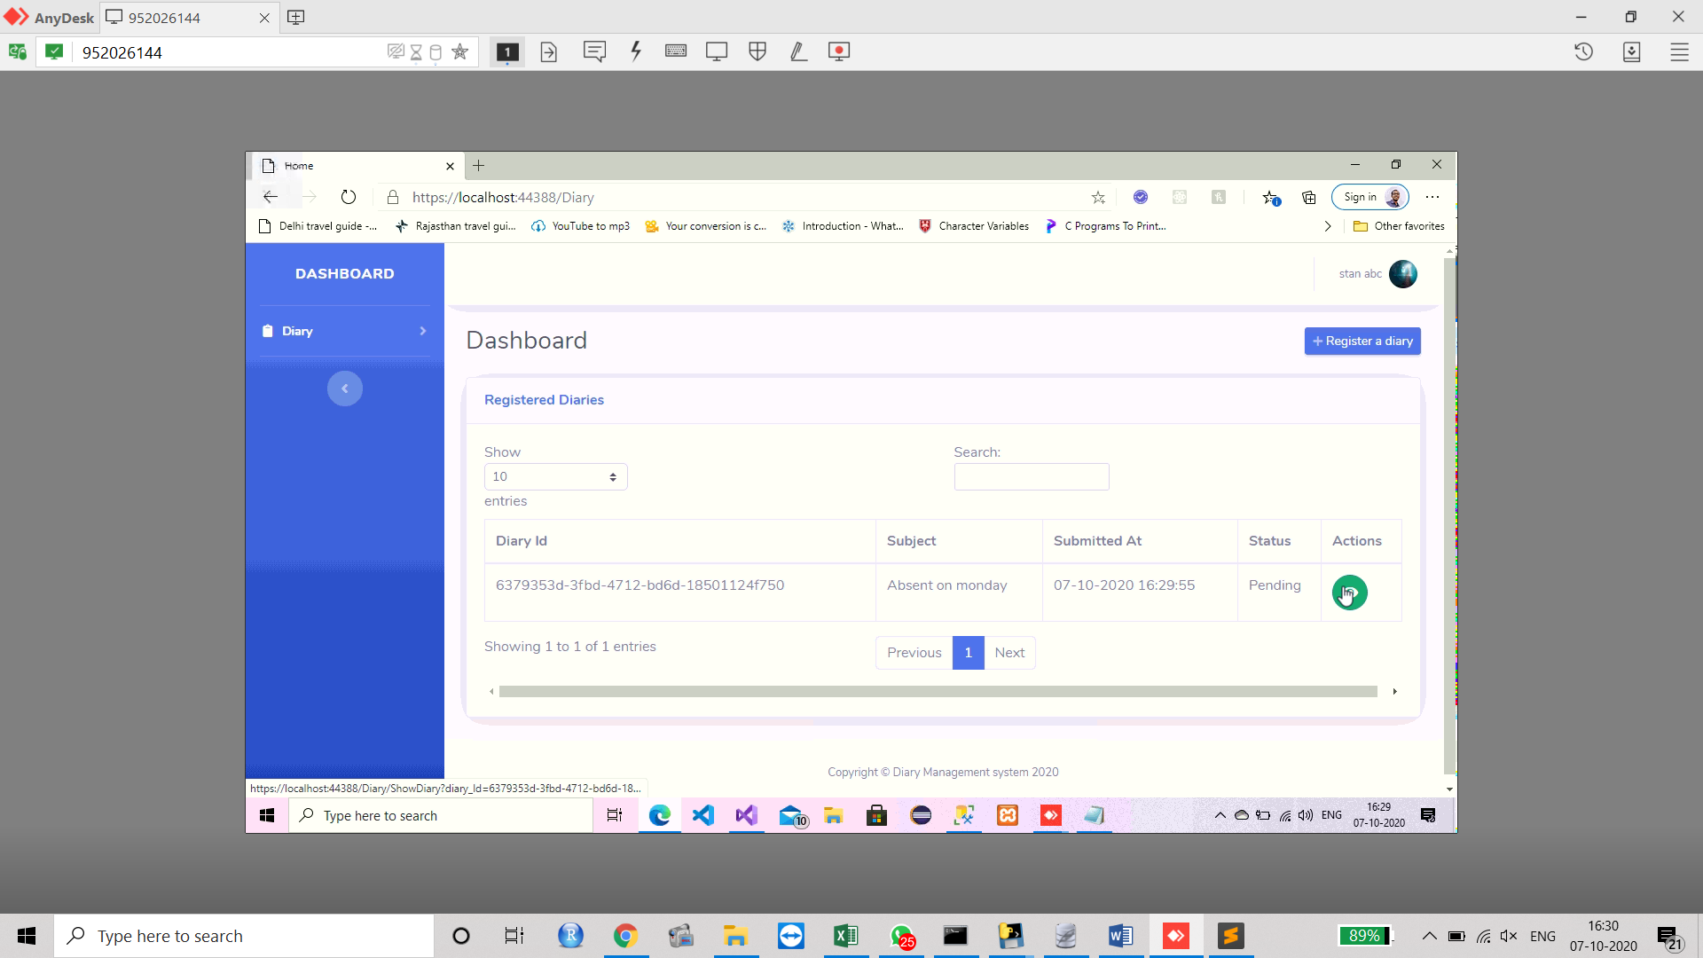

**Fig-8: Application sent to Teacher and Pending for approval**

In the meantime, if the student wants, he or she can change the subject of the application. They can also change the application body as per their requirement (Shin, 2020). However this facility is only available up to the status is pending.

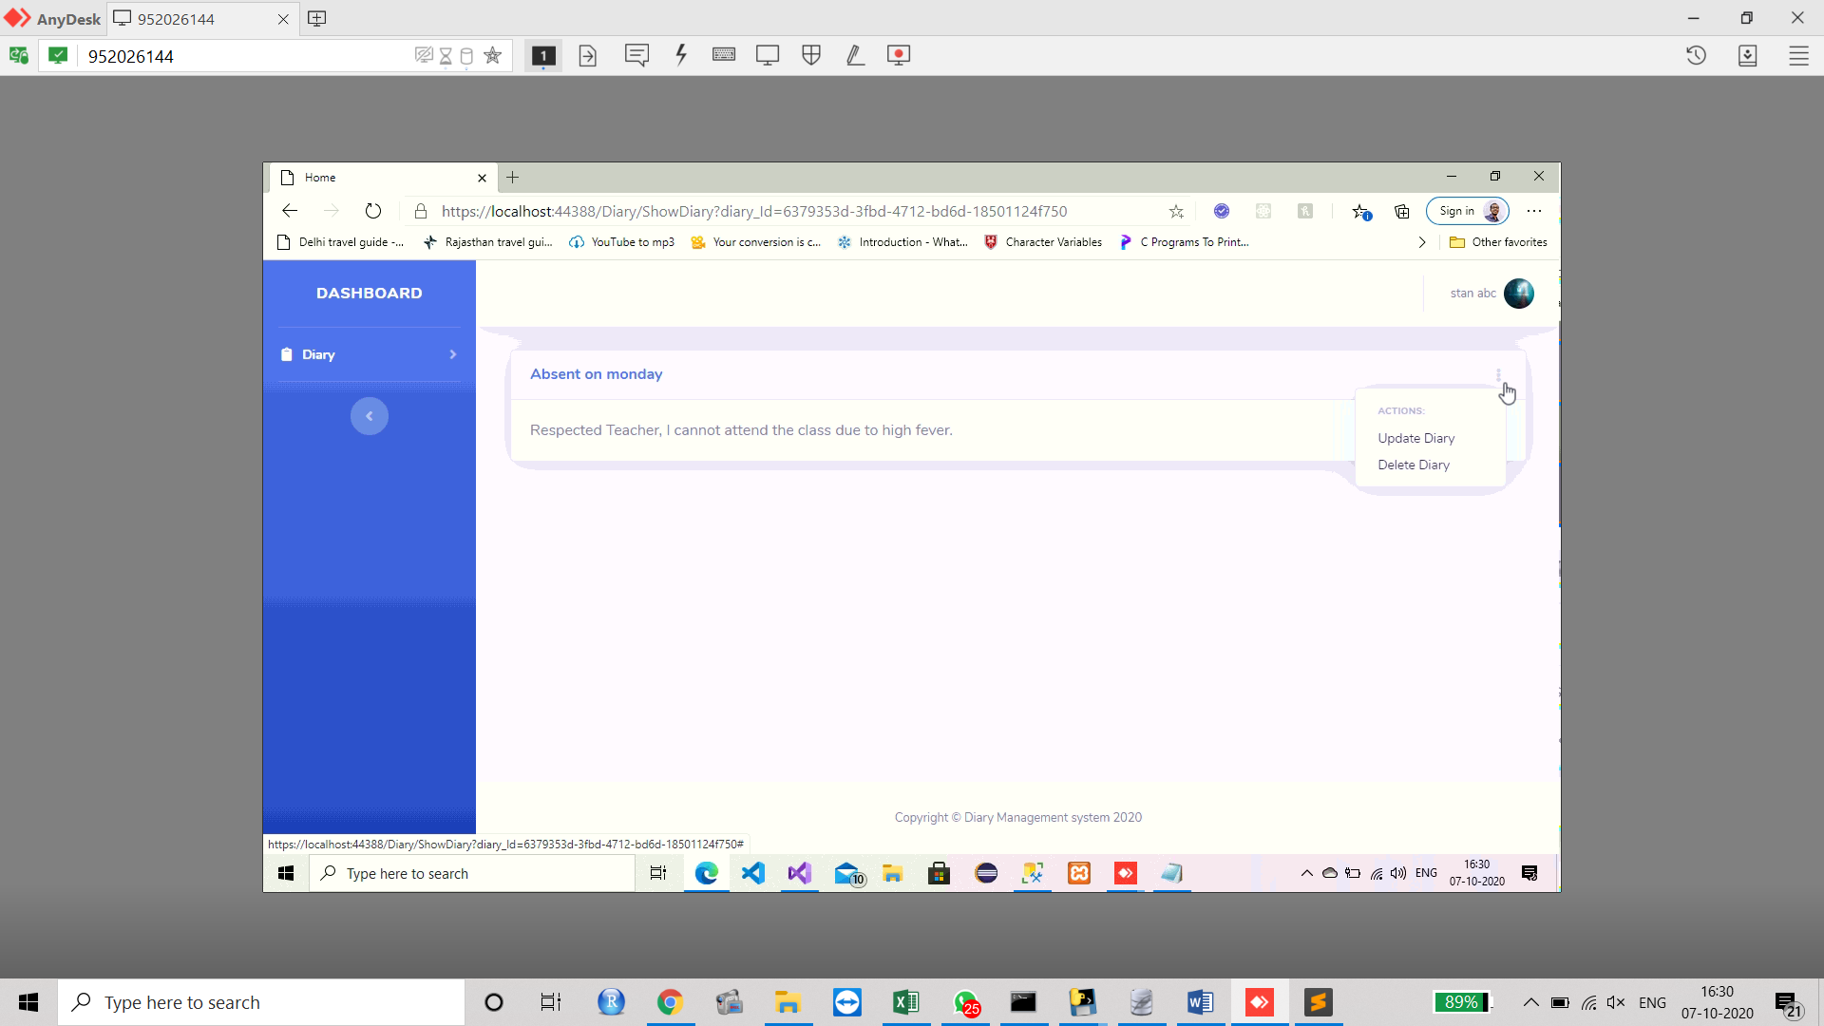

**Fig-9: Update or Delete Diary**

Now, the application or the diary has been sent to the corresponding teacher for approval. When the teacher will log in the system, they can check for the pending diaries from then dashboard. Once the teacher will check the pending diary, he or she can open it.

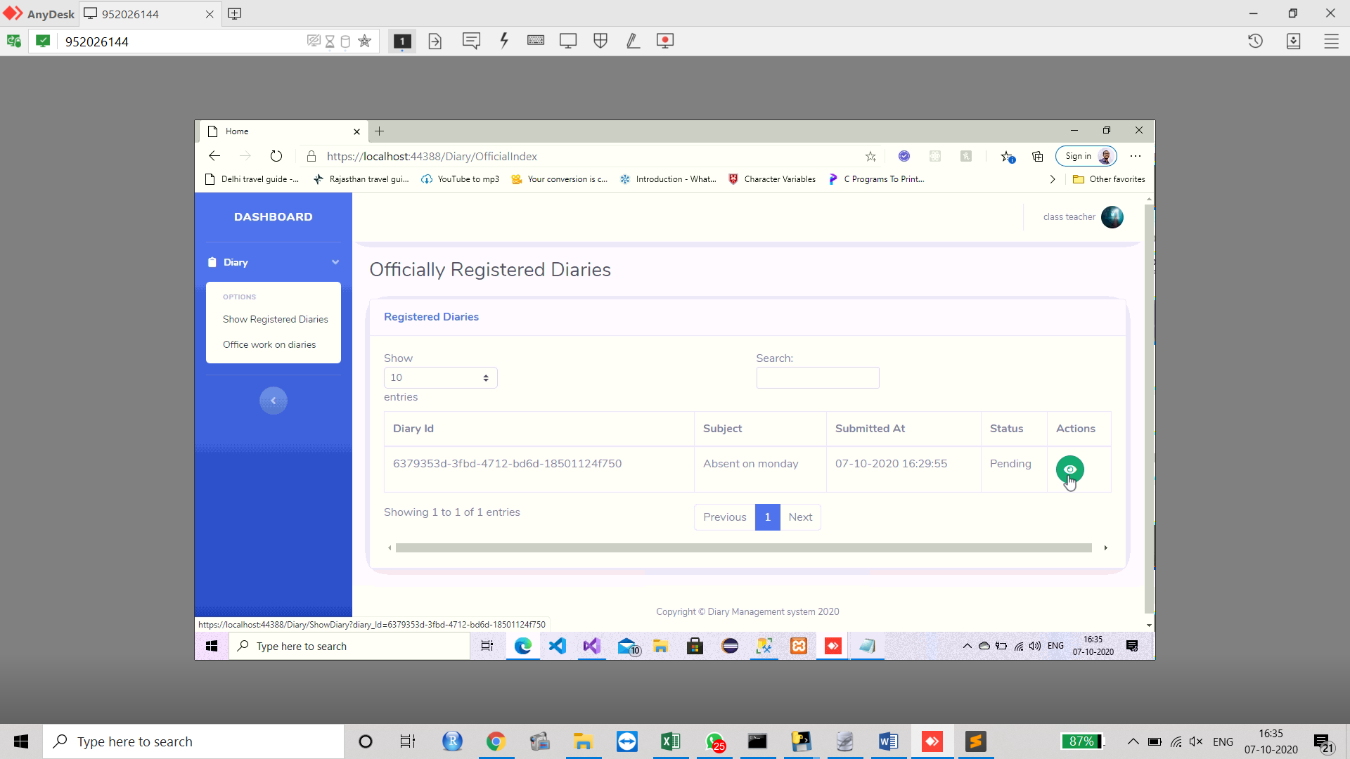

**Fig-10: Teacher Portal**

On viewing the diary of the student with some application for leave, the teacher can accept it or can reject it.

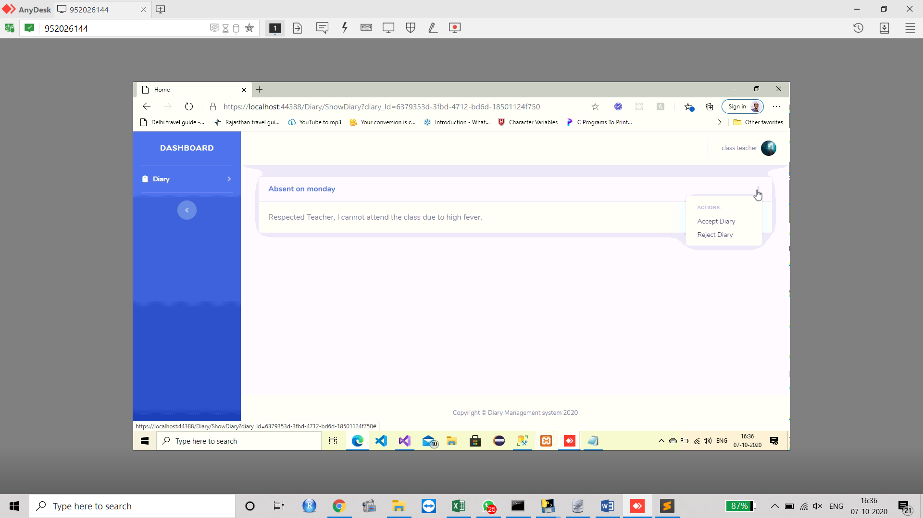

**Fig-11: Acceptance or Rejection by Teacher**

The acceptance of the rejection will be soon reflected the profile of student which had applied for the leave.

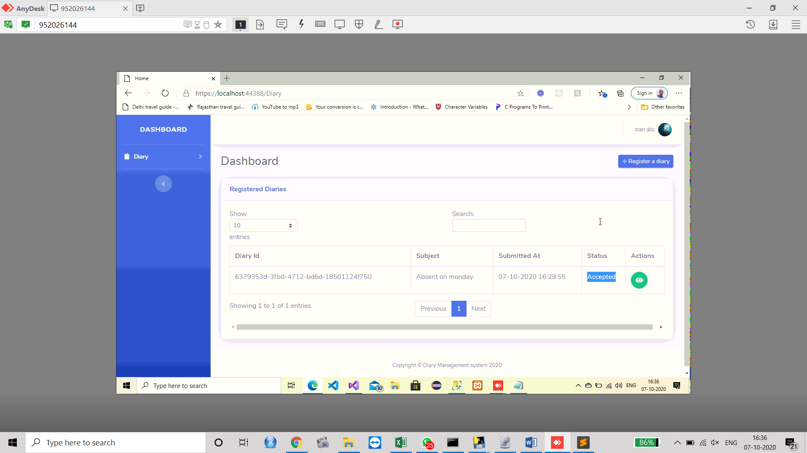

**Fig-12: Account of Student with the Acceptance Status**

This digital diary can be accessed from ten mobile also as it is made responsive (Refat, et al., 2019). The outlook of the diary in the mobile phone is shown below:

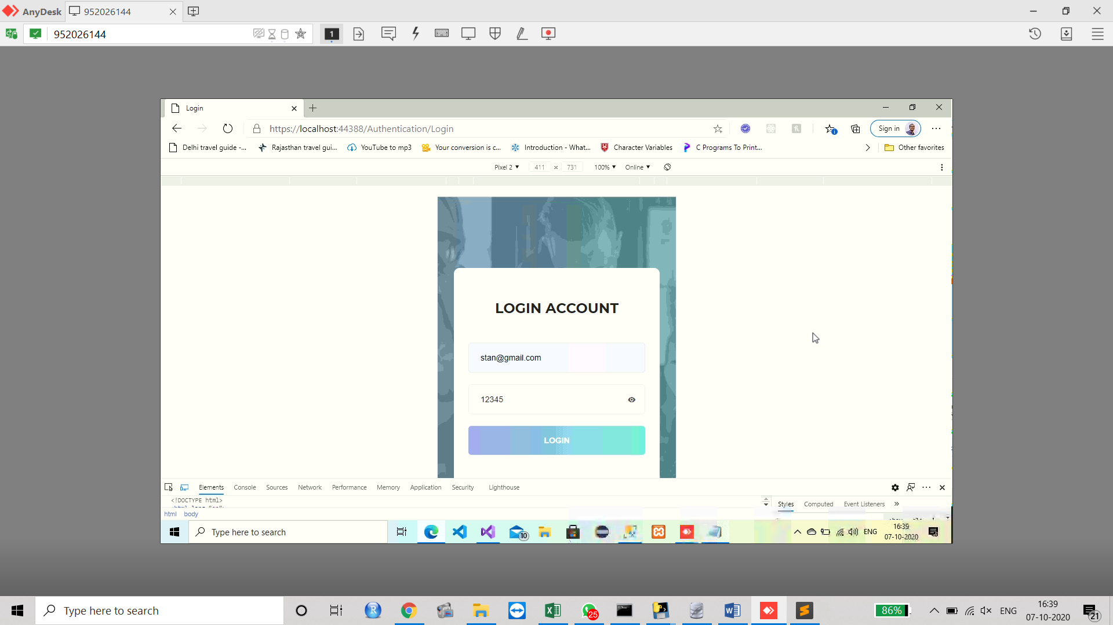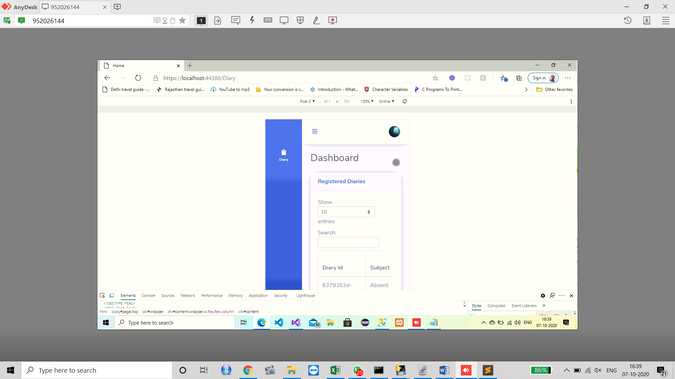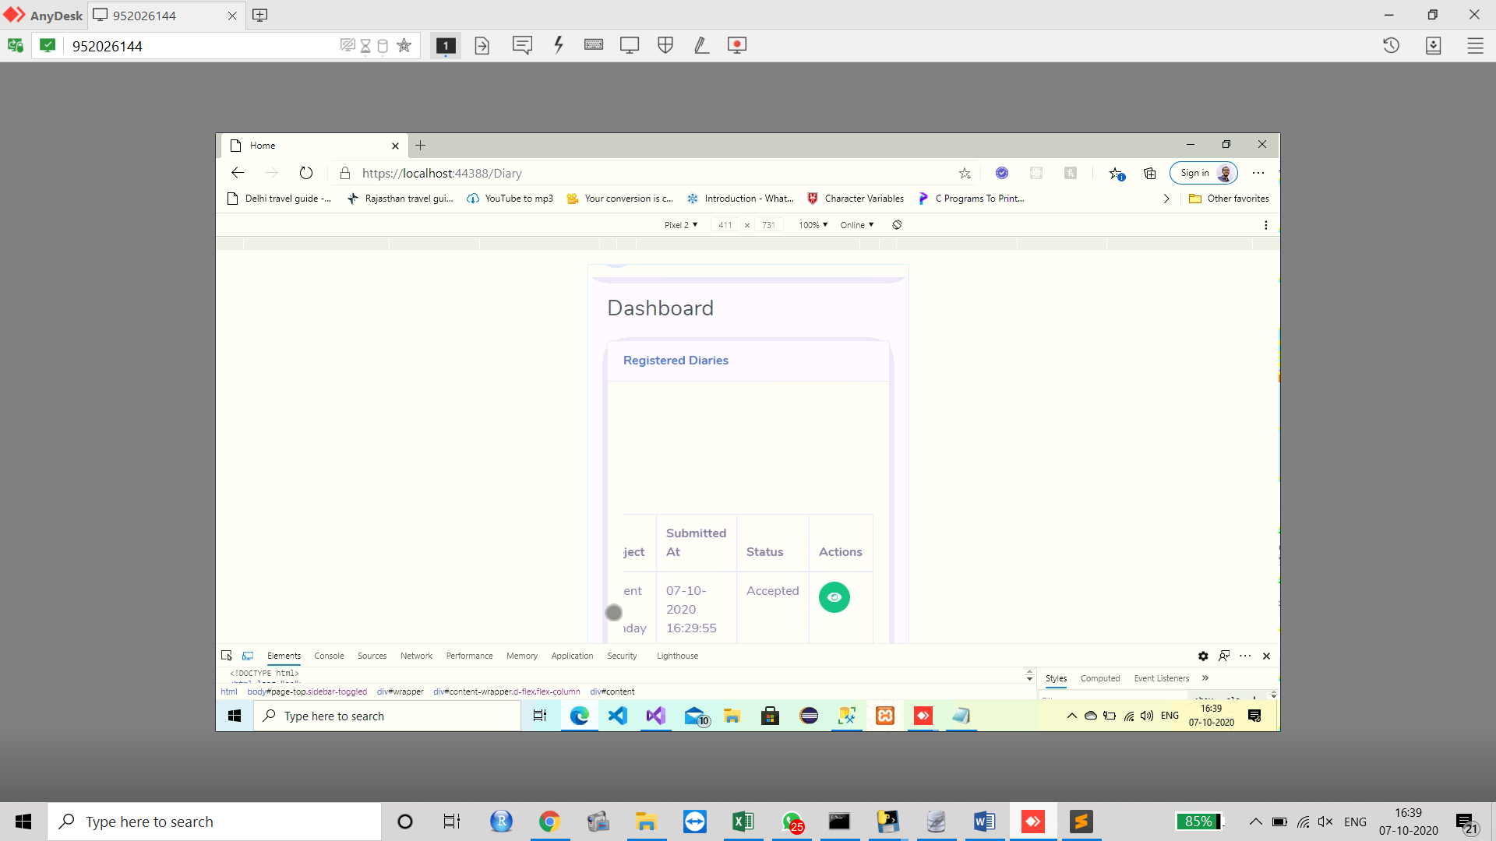

**Fig-13 Responsive Diary**

# **Conclusion**

In this paper, the Digital Diary has been designed on the basis of the Website format so that this can be availed by anyone and from any platform. The purpose of keeping a diary in a day to day basis is to avoid the nature of forgetting the issues that had been occurred to him in past. People also keep the diary to make the documents of their appointments and meeting in the future days which he might forget. To keep the memory updates, everything is recorded in the diary. Conventionally, people who keep the diary for recording the moments and appointments, generally access a pocket diary which is feasible and easy to carry. The diary provides the people with an intimate glimpse of his workings and feelings of his mind. The diary can also be considered to be the historical record of some continuous event which the people do not want to miss. In this paper, the diary is made to use for the educational system so that the student will be facilitated with the essence of service in the digital domains. In this design, the ASP.Net has been used with the integration of the MS SQL server where the data will be stored. The description of the Digital Diary system has been given in the operational view and the scenario has been analysed with all of the minute perspectives.

# **References**

Azmi, I. M. A. G., Zulhuda, S. & Jarot, S. P. W., 2012. Data breach on the critical information infrastructures: Lessons from the Wikileaks.

Baykara, M. & Gürel, Z. Z., 2018. Detection of phishing attacks. *2018 6th International Symposium on Digital Forensic and Security (ISDFS).*

Bhor, H. N., Koul, T., Malviya, R. & Mundra, K., 2018. Digital media marketing using trend analysis on social media. *2018 2nd International Conference on Inventive Systems and Control (ICISC).*

Blanco, R. & Tuya, J., 2017. Modelling Test Views for Graph Database Applications. *IEEE Latin America Transactions,* 15(2).

Bryan, C., Ma, K.-L. & Fu, Y.-C., 2013. An interactive visualization interface for studying egocentric, categorical, contact diary datasets. *IEEE/ACM International Conference on Advances in Social Networks Analysis and Mining (ASONAM 2013),* pp. 225-228.

Cao, T., Nguyen, H., Inoue, A. & Zhou, D., 2019. A Probabilistic Relational Database Model with Fuzzy Attribute Values. *IEEE International Conference on Fuzzy Systems (FUZZ-IEEE).*

Chen, X. et al., 2015. New Publicly Verifiable Databases with Efficient Updates. *IEEE Transactions on Dependable and Secure Computing,* 12(5).

Cunningham, S. J., Nichols, D. M. & Bowen, J., 2016. Personal video collection management behavior. *IEEE/ACM Joint Conference on Digital Libraries (JCDL).*

Debi, et al., 2020. Written or video diary-which one to prefer in teacher education and why?. *2020 IEEE 20th International Conference on Advanced Learning Technologies (ICALT),* pp. 124-129.

Fassbinder, A. G. d. O., Fassbinder, M., Barbosa, E. F. & Magoulas, G. D., 2017. Massive open online courses in software engineering education. *IEEE Frontiers in Education Conference (FIE),* pp. 181-184.

Ferrari, L. & Mamei, M., 2016. All-About Digital Diaries: Opportunities and Challenges. *IT Professional,* pp. 134-135.

Ferrari, L., Mamei, M. & Zambonelli, F., 2016. All-About Digital Diaries: Opportunities and Challenges. *IT Professional,* pp. 37-43.

Gadanecz, P., 2018. The nature of positive emotions via online language learning. *9th IEEE International Conference on Cognitive Infocommunications (CogInfoCom).*

Gogh, E., Kovacs, A. & Sziladi, G., 2017. Application of E-diary to analyze the effectiveness of learning. *8th IEEE International Conference on Cognitive Infocommunications (CogInfoCom),* pp. 81-85.

Jilek, C., Maus, H., Schwarz, S. & Dengel, A., 2015. Diary generation from personal information models to support contextual remembering and reminiscence. *Multimedia & Expo Workshops (ICMEW) 2015 IEEE International Conference,* pp. 1-6.

Kumar, A. & Panda, S., 2019. A Survey: How Python Pitches in IT-World. *International Conference on Machine Learning, Big Data, Cloud and Parallel Computing (COMITCon).*

Kwabena, O.-A., Qin, Z., Zhuang, T. & Qin, Z., 2019. MSCryptoNet: Multi-Scheme Privacy-Preserving Deep Learning in Cloud Computing. *Access IEEE,* pp. 29344-29354.

Lepp, L. et al., 2020. Written or video diary-which one to prefer in teacher education and why?. *IEEE 20th International Conference on Advanced Learning Technologies (ICALT),* pp. 331-335.

Liao, D. & Dogaru, T., 2016. Full-Wave Scattering and Imaging Characterization of Realistic Trees for FOPEN Sensing. *Geoscience and Remote Sensing Letters IEEE,* pp. 957-961.

Liao, J. et al., 2015. Smart Diary: A Smartphone-Based Framework for Sensing, Inferring, and Logging Users’ Daily Life. *IEEE Sensors Journal,* pp. 2761 - 2773.

Lin, H.-T., 2013. TripNote: A useful cloud-based trip diary system. *International Conference on Control, Automation and Information Sciences (ICCAIS),* pp. 121-124.

Miller, D., 2017. An ontology for future airspace system architectures. *Digital Avionics Systems Conference (DASC) 2017 IEEE/AIAA 36th,* pp. 1-8.

Rajkumar, R. & Ganapathy, V., 2020. Bio-Inspiring Learning Style Chatbot Inventory Using Brain Computing Interface to Increase the Efficiency of E-Learning. *IEEE Access,* pp. 67377 - 67395.

Refat, N. et al., 2020. MATT: A Mobile Assisted Tense Tool for Flexible m-Grammar Learning Based on Cloud-Fog-Edge Collaborative Networking. *IEEE Access,* pp. 66074 - 66084.

Refat, N. et al., 2019. Interactive Learning Experience-Driven Smart Communications Networks for Cognitive Load Management in Grammar Learning Context. *IEEE Access,* pp. 64545 - 64557.

Saks, K. & Leijen, Ä., 2019. Digital Learning Diary as a Tool for Enhancing EFL Learners' Metacognitive Reflection. *IEEE 19th International Conference on Advanced Learning Technologies (ICALT),* pp. 87-91.

Shin, S.-S., 2020. Structured Query Language Learning: Concept Map-Based Instruction Based on Cognitive Load Theory. *IEEE Access,* pp. 100095 - 100110.

Song, X. et al., 2018. Integrating Baseband Digital Optical Link and Six-Port Transceiver for Wireless Communications. *Asia Communications and Photonics Conference (ACP),* pp. 1-3.

Son, J., Choi, J. & Yoon, H., 2019. New Complementary Points of Cyber Security Schemes for Critical Digital Assets at Nuclear Power Plants. *IEEE Access,* Volume 7, pp. 78379 - 78390.

Son, J., Choi, J. & Yoon, H., 2019. New Complementary Points of Cyber Security Schemes for Critical Digital Assets at Nuclear Power Plants. *IEEE Access,* pp. 78379 - 78390.

Terenziani, P., 2016. Irregular Indeterminate Repeated Facts in Temporal Relational Databases. *IEEE Transactions on Knowledge and Data Engineering,* 28(4), pp. 1075 - 1079.

Terenziani, P., 2017. Irregular Indeterminate Repeated Facts in Temporal Relational Databases. *IEEE Transactions on Knowledge and Data Engineering,* 28(4), pp. 1075 - 1079.

Thams, F., Venzke, A., Eriksson, R. & Chatzivasileiadis, S., 2020. Efficient Database Generation for Data-Driven Security Assessment of Power Systems. *IEEE Transactions on Power Systems,* 35(1), pp. 30 - 41.

Vyawahare, H., Karde, P. & Thakare, V., 2018. A Hybrid Database Approach Using Graph and Relational Database. *2018 International Conference on Research in Intelligent and Computing in Engineering (RICE).*

Wada, M., Sano, M., Hatanaka, K. & Taka, H., 2012. Digital diary system for fishery and applications of fishery management. *2012 Oceans,* pp. 889-893.

Wang, J. & Zhang, D.-S., 2015. Research and Design of Distributed Database Synchronization System Based on Middleware. *2015 8th International Conference on Intelligent Computation Technology and Automation (ICICTA).*